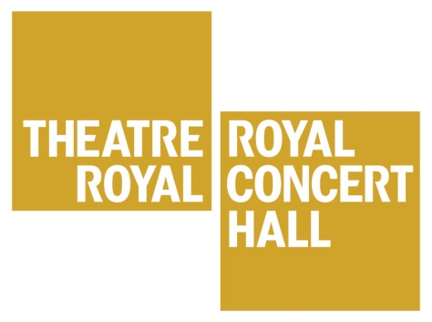
Summer School
Monday 30 July –
Friday 3 August 2018
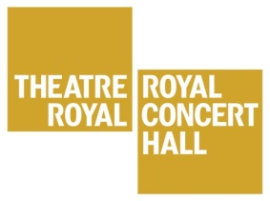
West End in Nottingham is back for 2018!

The West End in Nottingham Summer School is a great opportunity for young people to work with actual West End performers! Over 5 days, participants get to develop their own Musical Theatre talents as well as gain confidence, meet new people and, most importantly, have a lot of fun during the holidays!

Each day participants work with a performer from a different West End show. They will learn choreography, songs and scenes as well as get a chance to have their questions answered in the Q and A session with each West End Performer.

Dates and Times
The summer school is divided into two age groups:
- Participants aged 7-10 will meet from 9am to 1pm from Monday to Thursday.
- Participants aged 11-16 will meet from 1.30pm to 5.30pm from Monday to Thursday.
- Both groups will meet from 9am to 6.30pm on Friday.

Location: The Royal Concert Hall.
Access is available for wheelchair users or those with additional mobility needs.

Final Performance: The Royal Concert Hall, Friday, at 6pm.
This is a chance for the participants to share what they have been working on in the week. This performance is completely free for all family and friends of the participants.

Staff
The West End in Nottingham Course Director is Michael Park. Michael has worked professionally in the performing arts industry for many years as a performer and also in the education sector as a teacher, speaker and course leader. Michael will be supported in his work with an Assistant Director as well as four West End performers.
Administrative and front of house tasks for the Summer School will be co-ordinated by a member of the Theatre Royal and Royal Concert Hall’s Creative Learning team. They will be responsible for ensuring the security and health and safety of the students throughout the week.
On Friday, the day of the final performance, trained chaperones will be present to ensure the health and safety of the students, as in accordance with our child protection policy. All members of staff involved in this project are DBS checked.

Experience
No experience is required for this summer school. We are not looking for children and young people to have reached certain levels of acting, singing or dancing. Complete beginners are very welcome. We want the children to be challenged, but also to have fun and a great experience.

Cost and Enrolment
The cost of this Summer School is £80 per child. We consider this excellent value for money for five days of Musical Theatre. Children and young people will have the opportunity to work in depth with industry professionals and to perform on the stage of the Royal Concert Hall.

If you are interested in attending this year’s summer school then please complete and sign the Enrolment Forms at the back of this information pack. There can also be found a Photo Consent Form. Please then return along with your payment details as soon as possible.

Various conditions relating to the Summer School are listed on the Enrolment Form. Please make sure you are familiar and agreeable with them before you return the form.

As soon as forms and payment are received an email confirmation will be sent.

Places are awarded on a first come, first served basis.

Closer to the date of the Summer School we will contact you again to finalise details.
Please make sure that when enrolling a child or young person for this Summer School, that each and every participant must be available for all dates. We expect heavy demand for places.

In the meantime should you have any further queries then please do not hesitate to contact Caroline Pope on 0115 989 5627 or caroline.pope@nottinghamcity.gov.uk

WEST END IN NOTTINGHAM SUMMER SCHOOL
Monday 30 July to Friday 3 August 2018

Terms and Conditions

- The West End In Nottingham Summer School runs from Monday 30 July to Friday 3 August 2018
- The 7-10s will meet from 9am to 1pm from Monday to Thursday.
- The 11-16s will meet from 1.30pm to 5.30pm from Monday to Thursday.
- Both groups will meet from 9am to 6.30pm on Friday.
- All participants must be available for all of the dates of the Summer School.
- Participants are expected to arrive and be collected promptly, at the start and at the end of each session.
- A suitable drink and a light snack needs to be provided for every participant every day. A packed lunch will be required on Friday.
- All participants are expected to wear clothing conducive to movement and dance.
- Participants are expected to engage properly with Summer School staff, as well as fellow students throughout the time of the workshop.
- The total cost of the Summer School is £80 per child. This payment is required along with the enrolment form. A place cannot be confirmed until full payment is made.
- If all places on the Summer School have been filled, a waiting list system will then commence. In this situation, payment will be returned and the child’s details will then go on the waiting list. We will then only contact if a place does become available and payment will then be required.
- If the Theatre Royal and Royal Concert Hall is unable to attract sufficient participants to make the Summer School cost effective, the Theatre Royal and Royal Concert Hall has the right to cancel the workshop and a full reimbursement will be made to those already booked. This decision will be made no later than week beginning 11 June 2018.

If you are agreement with the above then please sign below and return this form.

Signed

Date

Relationship to child

Please return signed Terms and Conditions and Enrolment form to:

Caroline Pope
Creative Learning Officer
Theatre Royal and Royal Concert Hall
Theatre Square
Nottingham
NG1 5ND

WEST END IN NOTTINGHAM SUMMER SCHOOL
Monday 30 July to Friday 3 August 2018

Enrolment Form

One child per enrolment form please. If you wish to enrol siblings/friends please complete separate forms

Name of Participant
Address

Postcode

Date of Birth Age at Start of Summer School

Telephone

Parent/Guardian Email

Please provide an emergency name and contact number.

Any medical conditions/ailments we should be aware of?

Yes / No

If yes, please describe:

Please tick which group you wish the above child to be enrolled on:

7- 10s group

11- 16s group

I wish to pay the £80 Summer School fee by the following method (please tick):

Cheque Please enclose cheque, made payable to The Royal Centre, with your enrolment form.
Credit or Debit Card. We will contact you directly for your payment.
Cash. Please do not post. Enclose payment with your enrolment form and deliver to Theatre Royal Stage Door on Goldsmith Street. Please mark for the attention of Caroline Pope

OFFICE USE ONLY Payment Received;
WEST END IN NOTTINGHAM SUMMER SCHOOL
Monday 30 July to Friday 3 August 2018

Photograph Consent Form

During the course of the Summer School, the Theatre Royal will contact local media, such as the Nottingham Evening Post, to highlight the event. We shall also be taking photographs for our own documentation. These photographs may be used in future Theatre Royal publicity material

Please only complete and sign the following if you are happy for your child to be photographed during the Summer School.

I give my consent for my child

(please write child’s name)

to be photographed during the Summer School.

signed date

relationship to child

If signed and completed, please return this consent form to the Theatre Royal and Royal Concert Hall along with Enrolment Form.

A Musical Theatre Summer School

Monday 3rd – Friday 7th August

