Access Statement 2018
The Theatre Royal and Royal Concert Hall Nottingham are two of the UK's most successful touring venues, leading the way for arts and entertainment in the East Midlands region. Our diverse programme of events includes internationally renowned orchestras, the highest quality ballet, opera and touring drama alongside West End musicals, stand-up comedy, rock and pop.


The venue received the Access Excellence Bronze Award for the MIT Industry Awards in 2012 in recognition of our effort to provide accessibility for all, especially within the confines of a 150 year old building.

At the start of 2014, we were awarded bronze in the best practice charter by Attitude is Everything, an organisation that is at the forefront of improving Deaf and disabled people’s access to live music. Through continued improvements, and implementing further recommendations by AIE, we are delighted to announce the venue was awarded silver in spring 2015.



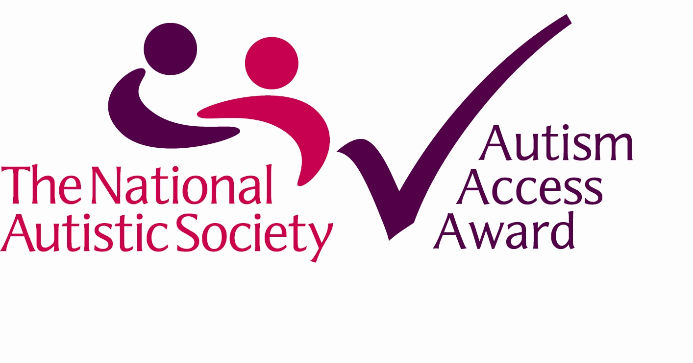
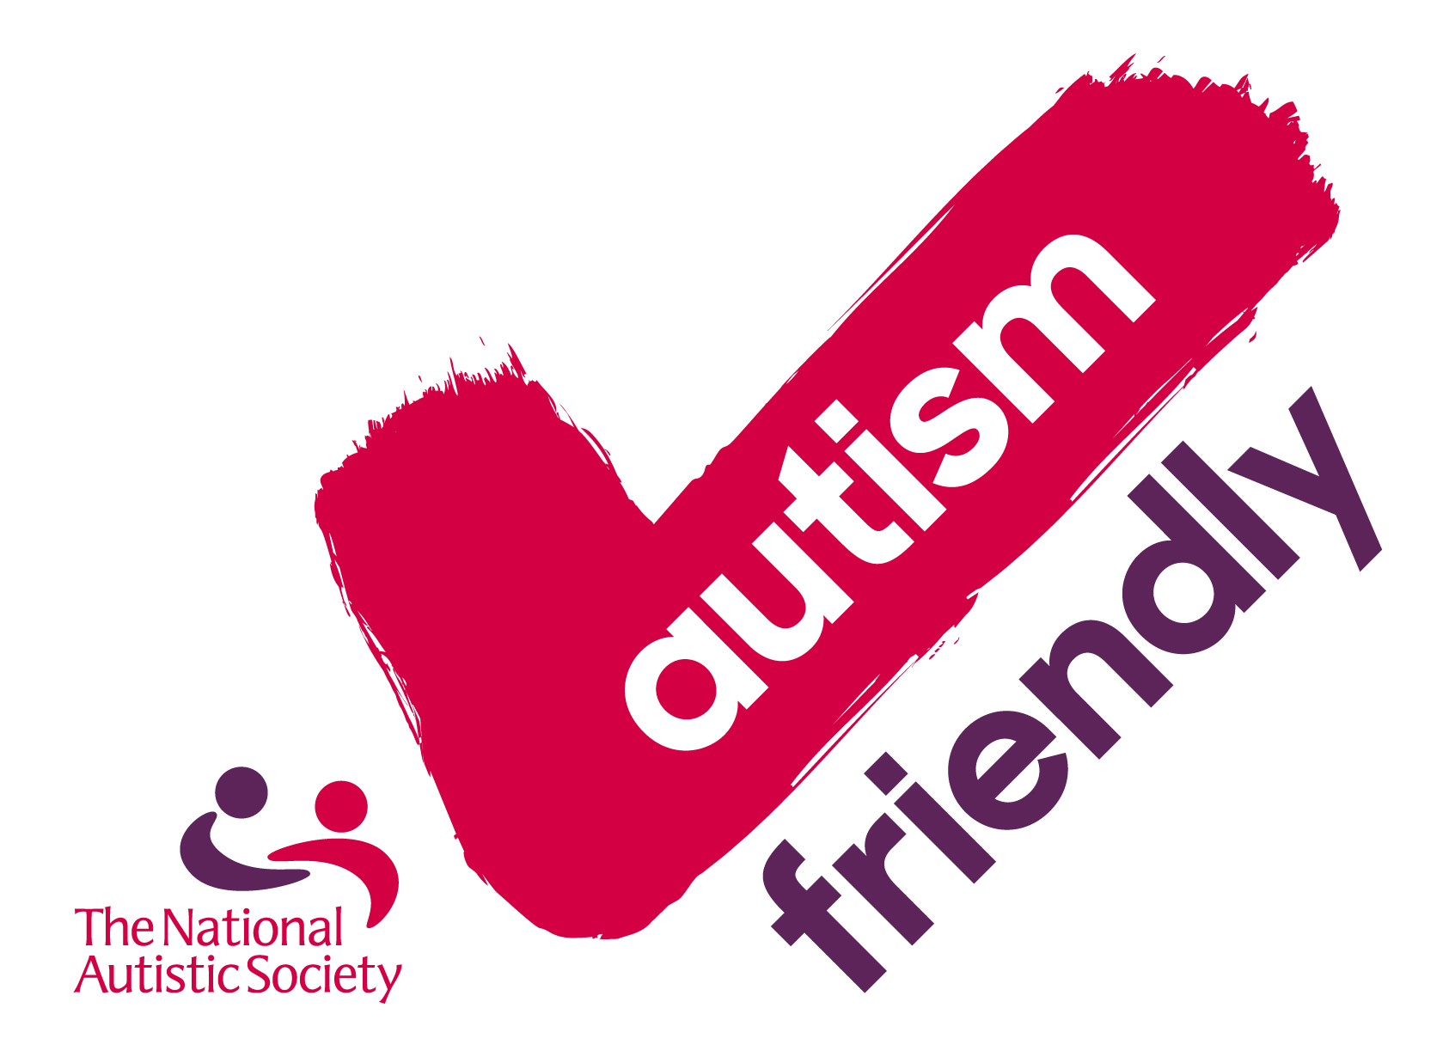
In recognition of the Theatre Royal and Royal Concert Hall Nottingham’s recent developments in providing a more autism-friendly environment, the National Autistic Society awarded the venue with an Autism Access Award, a new standard for customer-facing businesses, leisure services and cultural providers. We are delighted to have our Autism Friendly award renewed for 2018 by the National Autistic Society in recognition of our continued commitment, and development of services, for to a friendly welcome for all.

We have recently achieved CredAbility 'Verified Accessible' status. Our buildings have been assessed as meeting core accessibility standards for disabled people. A site visit and access audit of our facilities, covering areas like entrances, ramps, reception areas, lifts, toilets, lighting, acoustics, means of escape, access routes and more was completed. We are very proud to have attained this verification and look forward to continually improving access throughout both venues.
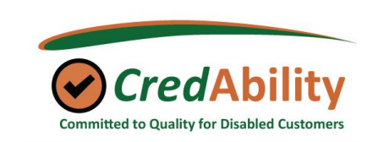
We continue to pursue ways in which we can improve access and communication with our customers, and we welcome comments on our current situation and are happy to receive suggestions for further improvements.

The Theatre Royal and Royal Concert Hall is firmly committed to enabling all our patrons to participate in our events equally and with dignity and respect.

For the purposes of this policy, "disability" is to be understood in the broadest sense of the word and covers all disabilities coming within the scope of the Equality Act 2010.

Key Aims
The key aims of this policy are to ensure that:
- all our patrons are able to access and enjoy live entertainment, music, dance and drama;
- disabled patrons are not treated less favourably for a reason relating to their disability than others to whom that reason does not apply;
- all reasonable steps are taken to prevent any of the physical features of the Theatre (or indeed our practices, policies and procedures) from making it unreasonably difficult for disabled patrons to make use of our services;
- all reasonable steps are taken to provide auxiliary aids and services to enable and assist disabled patrons in making use of our services;
- disabled patrons therefore feel as valued and experience the same high levels of satisfaction with our services as our other patrons.
Set out in the following pages are some of the ways in which we have sought to realise our key aims.
Staff

All staff have a responsibility towards access in the day to day running of the building.

The venue also has an Access Officer as well as an Access Front of House Manager contact during assisted performances. Members of the front of house team have received basic Sign Language training.

In addition to this, the venue has established an Access Champions working group (comprising of representatives from Backstage, Box Office, Marketing, Creative Learning, Facilities and Front of House) to help develop future initiatives at the venue.

During the show, the Duty Manager has overall responsibility for looking after our disabled patrons' interests and should be the first point of contact for any queries.
Members of staff are provided with regular basic training in disability awareness and etiquette, are aware of this policy and are able to assist patrons with queries regarding disabled access to the Theatre. This is also covered in the access section of the Staff Manual for everyday reference.
The Access Officer is a Dementia Friends Champion and carries out information sessions following Dementia Friends guidelines.
The Access Requirement Register

We have set up a free Access Requirement Register (ARR) in order to improve our service to customers. The information provided for the Register helps us to find the best available seats for customers quickly and easily and having this information on file will also save time when booking in future. Examples of access needs may include:

Wheelchair space
A bigger space required for a larger wheelchair or scooter
Wheelchair transfer seat on the end of a row
Aisle seat - left leg near aisle
Aisle seat- right leg near aisle
Space for assistance dog in the auditorium
Dog Sitting service
Infra-red hearing enhancement (Headsets and Neck Loops required)
Sign Language Interpreted Performance
Relaxed Performance
Audio Described Performance
Captioned Performance
Touch Tour
Guiding Assistance for blind or partially sighted customers
Storage of Walker or other equipment
(Some of the items are further referenced to in the subsequent pages of the Access Policy)

Customers can join the Access Requirement Register by filling in a form which is available from the Box Office or on our website (www.trch.co.uk).

An application can be completed by either the person with the disability or by the Personal Assistant if they will be booking tickets on behalf of the disabled person. If a Personal Assistant cares for more than one individual we ask that they apply separately for each person they assist.

Sections A and Section B will need to be filled out on all applications.

Section C will only need to be completed for the customers who require a complimentary Personal Assistant ticket, along with proof of eligibility.

Once completed, registration lasts for 3 years.

Those who need additional assistance
A free ticket for a personal assistant (PA) is available for any deaf or disabled person who has purchased a ticket to an event or performance and would be unable to attend without the help of their personal assistant.

The PA must be able to assist the deaf or disabled person to access the theatre and its facilities, remaining with them to ensure their wellbeing and comfort. Anyone designated as a Personal Assistant must be able physically to assist the person they are with to leave the building in an emergency.

A free PA ticket is available at the venue’s discretion to those who need assistance from another person in order to move around safely within The Theatre Royal and Royal Concert Hall buildings.

The following forms of evidence make an individual automatically eligible for a free Personal Assistant ticket in addition to their ticket:
- Front page of DLA (Medium or Higher rate)
- Front page of Attendance Allowance letter (no specific rate required)
- Front page of PIP (no specific rate required)
- Evidence that registered severely sight impaired (blind)
- Recognised Assistance Dog ID card
- CredAbility Access Card (with +1 icon)

We recognise that the evidence above might not include everyone that has an access requirement. If a customer does not have any of the above evidence but wishes to apply for a free ticket for a personal assistant, they can complete the Access Requirement Form, Section C, stating why they require a PA. Copies of additional evidence that support the application can be presented in person, posted or emailed and applications are assessed on a case-by-case basis.

Renewal of Access Requirement Register Card

We have created a simple renewal form for any customer who has been a member of our Access Requirement Register for three years and their card has, or is about to, reach its expiration date. The renewal process is easy and also offers customers a chance to update any of their details or a change in their personal circumstances.

Booking Tickets Online
If you are a member of the Access Requirement Register and are eligible for a free personal assistant ticket, you can now book these tickets online. If you would like to start booking online please call the box office on 0115 989 5555 or email tickets@trch.co.uk to get your account set up ready for online booking.
In 2018 we are continuing to focus our attentions on online booking for the customers who wish to use our Captioned, Sign Language Interpreted and Audio Described services, so please contact our box office on 0115 989 5555, email trch.access@nottinghamcity.gov.uk or send up a letter at The Theatre Royal and Royal Concert Hall, Theatre Square, Nottingham NG1 5ND if you would like to book tickets for these services.
Parking

The lay-by outside the Royal Concert Hall main entrance on South Sherwood Street (GPS nearest postcode NG1 4BY) can be used for arrival and collection of customers. Parking in the lay-by is not permitted.
Parking spaces for Blue Badge holders are located on Burton Street at the Rear of the Royal Concert Hall (GPS nearest postcode NG1 4BU) and Wollaton Street near the Royal Centre tram stop (GPS nearest postcode NG1 5FW).
The venue has no on site parking however parking is available a short distance from the venue. There are several car parks within a 5 minute walk including Q-Park at Talbot Street, an NCP car park at Trinity Square and the Crowne Plaza Hotel.

Access to the Theatre
More information on access to the theatre can be obtained from our website www.trch.co.uk/acess

Level Access Into the Building
There is level access to the Theatre Royal via the stalls bar entrance on South Sherwood Street, opposite the main entrance to the Royal Concert Hall.

From South Sherwood Street there is level access into the Royal Concert Hall via the automated door on the far right of the main entrance.

Inside the Venue

Ramps
Ramped access to the Theatre Royal is to the far left of the portico entrance. These doors are automated.

During performances, ramped access to the Royal Concert Hall is available from Burton Street.

Lift Facilities
There are lifts available in both the Royal Concert Hall and the Theatre Royal.

Stairs
If you prefer level access in the auditorium, we would advise you to book in the stalls of the Theatre Royal. There are flights of stairs to seats in all upper levels.

All levels of the Royal Concert Hall are accessible by lift. There are a small number of stairs to reach some seating on Tier 1 and Tier 2.

Toilet Facilites
Both the Theatre Royal and Royal Concert Hall have adapted toilets available for customers with disabilities.

Further assistance for deaf and hard of hearing people

Both the Theatre Royal and Royal Concert Hall have an infra-red Sennheiser transmission system to relay sound to customers who require it.

Headsets and Neck Loops are available free of charge from the Access desk in the Theatre or the Cloakroom at the Royal Concert Hall. If you would prefer to use your own headphones with our Neck Loops, please ensure they have a standard 3.5mm headphone jack, of the same size that fits into your mobile phone, laptops or mp3 devices. These can be used with our Infra-Red receivers.

If you wish to use this service, we ask that you inform the box office staff when booking tickets so that they can best advise the best areas of the auditorium for optimum transmission quality.
These systems are regularly checked to ensure that they are operating correctly.

Information Sheets on both the Receivers and about seats in the optimum transmission areas are available from the access section of our website www.trch.co.uk. Hard copies can be obtained from the Access Desk and the Box Office.

If customers prefer to use the typetalk service or email we welcome these as a means of booking tickets.

Facilities for customers who are blind and partially sighted

An Audio CD, Large Print and Braille version of the seasonal brochure are available upon request.
Large Print and Braille programmes are provided during Audio Described Performances.

Assistance Dogs

We welcome guide dogs and assistance dogs. A dog sitting service is offered to patrons who do not wish to take their dog inside the auditorium. Please advise the Box Office at the time of booking, so that suitable arrangements can be made or contact the Access Officer on 0115 989509.

Site visits

Patrons and their companions are welcome to visit the Theatre prior to attending a performance in order to familiarise themselves with the venue's layout. These visits can be arranged through our Access Officer.

Additional assistance on the day of your visit

The Theatre Royal and Royal Concert Hall are committed to making everyone’s visit enjoyable. Additional assistance we can offer is not limited to our assisted performances. Examples of additional assistance are:

Finding a quiet space for you and your companions

Discussing merchandise options (if applicable) in advance if you or your companions are unable to queue.

Use of a wheelchair should you or your companion require one on the day of your visit. (Please be aware we have a limited number of wheelchairs)

If you have any further requests or questions in regards to your visit, please contact the access department on trch.access@nottinghamcity.gov.uk. You can also call and speak to our box office staff on 01159895555.

Theatre Royal and Royal Concert Hall staff are there to help you. If you need any further assistance on the day of your visit, please talk to a uniformed member of staff.

Wheelchair spaces

Wheelchair spaces are currently located at the rear of the Stalls and on the Dress Circle of the Theatre Royal. In the Royal Concert Hall wheelchair spaces are located on the right hand side of the Stalls and either side of the auditorium on Tier 1.

Scooters and large size wheelchairs may require the allocation of two standard size wheelchair spaces. Please advise us of your needs at the time of booking.

Wheelchair Transfers and Walkers
Our staff will look after your walker or wheelchair once you have transferred to your seat.

Assisted Performances

Please state at time of booking if you require any of the services listed below as the box office will be able to advise you of the best places to sit in the auditorium.

The Theatre Royal and Royal Concert Hall hold regular Sign Language Interpreted, Audio Described and Captioned performances for selected performances. Details of these shows may be obtained upon request from the Box Office and will be included within the Seasons Brochure, as well as on the theatre's website www.trch.co.uk. These can also be sent out as attachments to customers on the access mailing list. We have also held relaxed performances of our pantomime and hope to schedule more with future productions.

Sign Language Interpreted Performance for users of British Sign Language.

A BSL interpreted performance is where the vocal line is interpreted into sign language. The interpreter stands at the front of the stage to one side allowing you to view both the signer and the production

Audio Described Performance for blind or partially sighted patrons
Live commentary via personalised headphones.
Braille and Large Print cast lists will be available for these performances, with programme notes broadcast 15 minutes prior to the performance
Touch tours allow visually impaired customers a unique opportunity to go onto the stage and explore the sets, costumes and props before the performance begins

Captioned Performance for people who are hard of hearing.

Dialogue, sound effects and lyrics are displayed in English text a unit located at the side of the stage.

Relaxed Performances

Specifically designed and adapted for customers with a wide range of disabilities and those on the autistic spectrum, as well those living with dementia and families with young babies. They have a less formal, more supportive atmosphere in order to reduce anxiety levels. The lights will remain up in the auditorium and loud sound effects will be dampened. Customers are free to move around and make noise, or leave the theatre at any time. We also produce visual stories to help prepare customers for their visits.

Safe Places

We are part of the Safe Places Scheme:

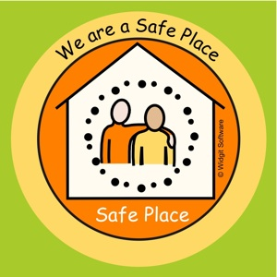

The scheme enlists local businesses and public places within the local community where vulnerable people can go when they are in distress and in need of assistance.
The safe place will supply basic support to the individual to help them contact their friends, family, carers / support workers and the emergency services, if a crime has taken place.

Dementia Awareness

Music and Theatre play an important role in engaging with People who are living with Dementia and can contribute significantly to maintaining people’s independence and reduce social isolation.

The Theatre Royal and Royal Concert Hall is supporting Dementia Friends, an Alzheimer’s Society initiative, to help people develop an understanding of dementia and turn into action to support customers and employees who are affected by the condition.

We realise that some customers living with Dementia may find everyday ambient noises or unidentified environment factors a source of anxiety.
We have some lighting mechanisms, air conditioning vents and speakers in various locations of the Theatre Royal auditorium. On the following seating plan we have marked the main positioning of these are and the surrounding seating areas they may be effected.
We would also like to point out that there is uneven flooring in the stalls on the Right Hand Side on the end of J1, H1 G1 and F1.
Customers seated on the Left Hand side of the Theatre Stalls may feel some intermittent vibrations from the Nottingham Trams outside.
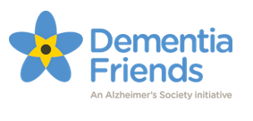



The Theatre Royal and Royal Concert Hall is a member of the Dementia Action Alliance; a movement with one simple aim: to bring about a society-wide response to dementia.
We have worked in conjunction with Alzheimer’s Society to implement a pilot project of reminiscence workshops as well as trips to see performances. A Dementia Friendly information flyer has been created, with input from our local Service User Review Panel. This guide helps to explain, in an easily digestible format, the various services and facilities on offer at the venue for People Living with Dementia.



We are a member of the ‘Take a Seat’ initiative. Businesses and community premises across Nottingham are offering older people a chance to sit down and catch their breath when they are out and about

Take a Seat is a very simple cost free approach - enabling older people to feel safe, remain independent and endeavours to reduce social isolation.

Contact Details

Email: trch.access@nottinghamcity.gov.uk

Postal Address

Access Requirement Register

Nottingham Theatre Royal and Royal Concert Hall

Theatre Square

Nottingham

NG1 5ND

Box Office: 0115 9895555

