*only applicable on Audio Described Performances*

Blind / Partially Sighted and Hard of hearing (e.g wishes to use the AD facility and wears a hearing aid)

Please ensure the hearing aid is set to the “T” setting

3 x options available

Blind / Partially sighted and using the AD facility (only applicable on Audio Described Performances)



Place Battery here

Select channel 2



**OR**

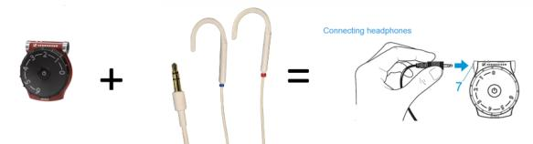

**OR**

**OR**

Select channel 2 - lit up amber. *(will flash when not in auditorium, when connects inside this light will switch to constant initially and then will go out after a minute or so (it is still connected to the AD)*

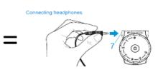



Select channel 2 - lit up amber. *(will flash when not in auditorium, when connects inside this light will switch to constant initially and then will go out after a minute or so (it is still connected to the AD)*

On / off button

To adjust volume – toggle

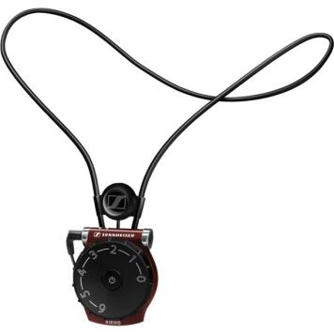

Place Battery here

To adjust volume toggle

To turn on pull the earbows of the receiver apart

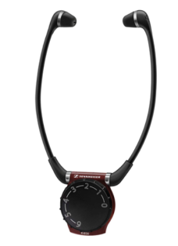

Place onto setting ‘II’ for channel 2 (AD channel)

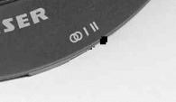

On / toggle off and Volume adjust

Place Battery in here

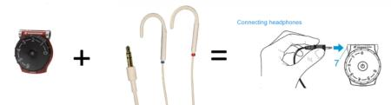

Hard of hearing **and** wears hearing aid(s)

Please ensure the hearing aid is set to the “T” setting

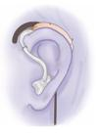

**OR**

**OR**

Select channel 1

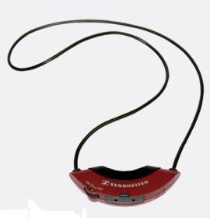



**OR**

Select channel 1

To adjust volume toggle

Place Battery in here

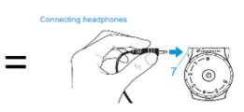

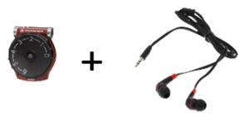

Hard of hearing only (e.g customer does not use hearing aids) 3 x options available

To turn on pull the earbows of the receiver apart

Place Battery here

Select channel 1 - lit up amber.

On / toggle off and Volume adjust



Place onto setting ‘I’ for channel 1

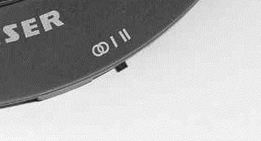

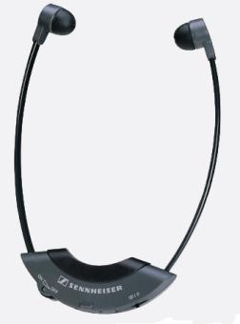

To adjust volume – toggle

Select channel 1 - lit up amber.

Place Battery here

On / off button

Place Battery in here

On / toggle off and Volume adjust