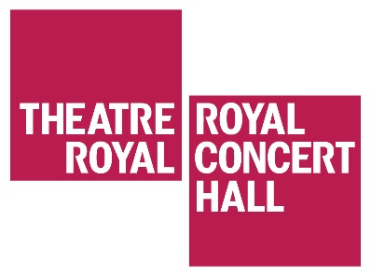
HEDDA GABLER STUDENT SYMPOSIUM

Thursday 8 February 2018 10.30am to 3.30pm
Theatre Royal Nottingham

This event will be taking place on the Theatre Royal stage with general seating available in the stalls. Refreshments will be available all day from our new Yarn café.

10.30am – Welcome & Outline of the Day
David Longford, Creative Learning Manager
Theatre Royal & Royal Concert Hall Nottingham

10.40am – Session 1 Panel Discussion
Themes, Character and Re-Staging Classical Canon as Contemporary Production
Chair: Dr Jo Robinson, Associate Professor in Drama and Performance, University of Nottingham
Panel: Sarah Grandage, Lecturer in Drama, Performance and Language, University of Nottingham; John Stokes, Emeritus Professor at King’s College London; Rachel Lincoln, National Theatre Touring Director

11.20am – Break

11.30am – Session 2 Panel Discussion
Ibsen and the Role of Women
Chair: Sarah Grandage
Panel: Jo Robinson John Stokes, Lizzy Watts (actor playing Hedda Gabler – tbc)

12.30pm – Lunch

1.30pm – Session 3 – National Theatre Page to Stage
Scene Study & Q&A with Rachel Lincoln and members of the Hedda Gabler company

3.15pm – Final Questions & Close

For any further enquiries about this event please contact David Longford on 0115 9895531 or david.longford@nottinghamcity.gov.uk

