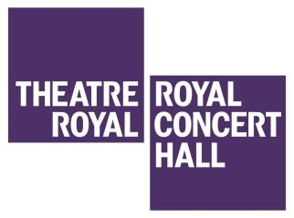

TRCH
Delivering Quality Customer Care

Name:

Q - Why do you wish to work at the Theatre Royal and Royal Concert Hall?

- Our Customers

Customers have high expectations when they visit the Theatre Royal and Royal Concert Hall. One reason for this is the amount of money they spend. This can include: the journey to and from the venue; tickets; food and drink, and programmes / merchandise.

Q - Why are members of the public important to our business?

- First Impressions

When our customers visit the Theatre Royal and Royal Concert Hall they will judge us on how we look, what we say, and how helpful we are. This will be in the first few seconds of coming into contact with us. We need to make sure the customer’s first impression of the Theatre Royal and Royal Concert Hall is a great one.

Q - How can you create a great first impression?

Communicating with our customers

We have all heard the expression “it’s not what you say; it’s the way that you say it”. A customer could have the same conversation with two different staff members but with very different outcomes. Some words are very emotive and if said in the wrong way can create unnecessary reactions.

Q - How would you re-word the following statements? Remember: Tell people what you can do, not what you can’t.
Statement | Q - How would you re-word the statement?
1. That is not right
2. Wait here
3. I can’t do that for you
4. You have to
5. It’s not my job
6. I don’t know

