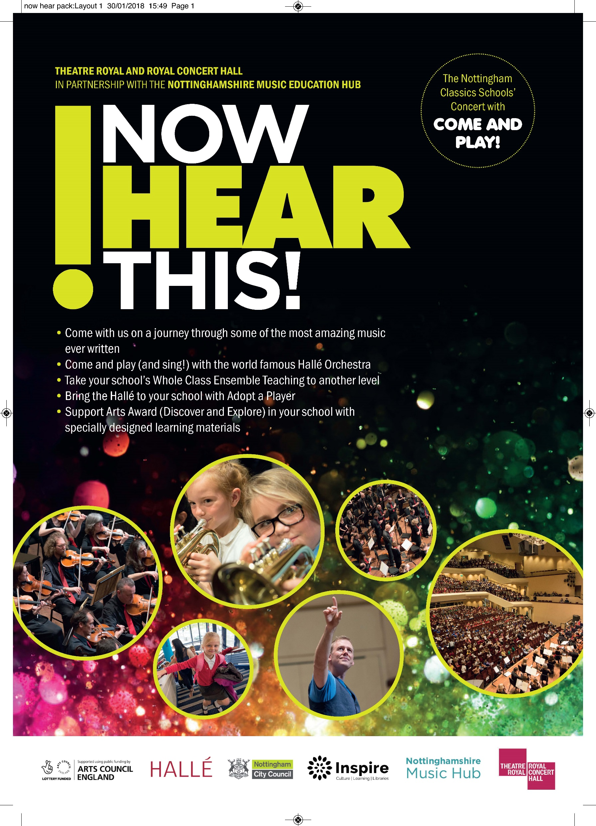

Theatre Royal and Royal Concert Hall in partnership with the
Nottinghamshire Music Education Hub
NOW HEAR THIS! –
Strictly Hallé!
Thursday 28 June 2018, 1.30pm

Featuring music from:

Tchaikovsky Prelude to Swan Lake
Copland Hoedown from Rodeo *
Saint-Saëns Danse Macabre
Tchaikovsky Waltz of the Flowers *
Dvorak Slavonic Dance (choice of Op. 46, No. 8 or Op. 72 No. 2)
Marquez Danza No. 2

With the chance to perform with the Hallé in:

Prado Mambo No. 5
Steve Pickett British Folk Dances
Mark & Helen Johnson Ai Caramba Samba
Steve Pickett & Neil Bennison Charleston Champions

* BBC Ten Pieces

Conductor Jonathon Heyward
Presenter Tom Redmond

Now Hear This is a fun-packed, fast-paced introduction to classical music and the instruments of the orchestra for schoolchildren aged 8 to 11, with the chance to join the world famous Hallé in making a sensational sound.

Your guides to the music are conductor Jonathon Heyward and presenter Tom Redmond. This year’s concert is all about dance – whirling from waltzes to mambos in an hour of glittering music to light up the Royal Concert Hall.

The Hallé’s Education Director, Steve Pickett, has arranged Perez Prado’s jumping and jiving Mambo No. 5 for schools to perform with the Hallé, as well as a set of lively British Folk Dances. Apart from supporting progression routes for young musicians these Come and Play pieces offer an amazing and inspiring experience that they will never forget.

Steve has arranged two songs – Mark and Helen Johnson’s Ai Caramba Samba and a new song, Charleston Champions - for everyone to sing with the Hallé in the concert. To assist with rehearsal in the classroom, the scores, parts and MP3 sound files for the participatory pieces can be downloaded from the Nottinghamshire Music Hub website at www.inspireculture.org.uk/nowhearthis from this February.

Now Hear This also offers fantastic opportunities to make music come alive before and after the concert. We offer the unique opportunity to Meet the Musician, when a Hallé player visists your school, as well as support materials for students taking the Discover and Explore Arts Awards.
The performance is open to all primary schools from across the city and county.

Read on to find out what’s on offer …
What’s on offer…

1. Come to the concert
Tickets for the concert are just £3. Each participating school receives a
FREE Teacher’s Pack with learning resources and a CD so that you can get to
know the pieces before the concert.

Every school gets a chance to perform with the Hallé when we’ll all be singing
Ai Caramba Samaba by Mark and Helen Johnson and Charleston Champions by Steve Pickett and Neil Bennison.

To book for the concert (including singing with the Hallé) fill in Form A on page 4.

2. Come and Play Performance
If your school is taking part in Whole Class Ensemble Teaching (WCET) then your instrumentalists can join the Hallé in the performance of Perez Prado’s Mambo No. 5 and Steve Pickett’s suite of British Folk Dances.

NB: Your students must learn the pieces in the period up to 28 June 2018. It is essential that your instrumental /WCET tutors devote sufficient time to coaching each group. If you require additional support please contact musichub@inspireculture.org.uk.

To book for the Come and Play performance, fill in Form B on page 5.

PLEASE NOTE: If you are bringing both performers and non-performers to the concert please complete both forms (A and B) to book their tickets.

3. Meet the Musician
Schools in the city and county can get to know the Hallé better by meeting one of its players. Hallé players will visit your school, lead some creative music work based on the concert and meet your school party at the concert. A Meet the Musician session will contribute towards your students’ Arts Award journey.

There are 20 Meet the Musician places available. These are FREE but will be allocated on a first come, first served basis. Please make sure that you tick the box at the bottom of your booking form to apply.
Booking Form A: Hallé Performance Only

Use this form for those students and staff who are coming to the concert but who will not be playing a musical instrument in the Come and Play Performance. All schools get to sing with the Hallé.

Please note: If you are also bringing instrumentalists to take part in the Come and Play performance then please also complete Booking form B on Page 5 to book places for those students and staff.

We are a City school County school

We would like to book _____ tickets @ £3 each for Now Hear This on Thursday 28 June at 1.30pm.

Title…….First name……………………….………….Last name…………………………………………………………………

Name of School:……………………………………………………………………………………………………………………………

Postal Address………………………………………………………………………………………………………………………………

……………………………………………………………………………………… Postcode………………………………………………

E-mail address (preferably the music co-ordinator’s) …………………………………………………………………………

Tel. No:……………………………………………………Fax No:………………………………………………………………………

I enclose a cheque/PO made payable to the ‘Royal Centre’ for £………………………………………

Please charge £……….to my master Card/Visa/Switch Card (please delete as appropriate)

Card Number _ _ _ _ | _ _ _ _ | _ _ _ _ | _ _ _ _ | Expiry Date _ _ | _ _

Issue Number (Switch/Maestro only) _ _ Security number (3-digit number on reverse) _ _ _

Meet the Musician
We would like to meet a Hallé musician

Now post the form, with your payment to: Kimberley Allsop, Royal Concert Hall,
Theatre Square, Nottingham NG1 5ND. Your tickets will be sent to your school
as soon as we have received payment.

Booking Form B: For schools taking part in the Come and Play Performance

Please note, if your school is also bringing non-instrumentalists to hear the concert then please use Booking form A on Page 4 to book places for those students and staff.

Schools taking part in the Come and Play performance must arrive at the Royal Concert Hall at 11.00pm, for the rehearsal at 12.00pm. If you are bringing a mixed party of both performers and non-performers and need to travel together, you should arrive at 12.00pm.

We are a City school County school

Title…….First name……………………….………….Last name…………………………………………………………………

Name of School:……………………………………………………………………………………………………………………………

Postal Address………………………………………………………………………………………………………………………………

……………………………………………………………………………………… Postcode………………………………………………

E-mail address (preferably the music co-ordinator’s) …………………………………………….………………………………

Tel. No:……………………………………………………Fax No:………………………………………………………………………

Enter the number of instruments/performers you will be bringing below. All places are £3 each.

- Always use a new line for each different instrument.
- You cannot bring more performers than you actually have instruments for.
- A staff member/supervising adult (they don’t have to play an instrument) must be seated with each group.

e.g.
Instrument violin No. of student players 12 No. of staff players 2

Instrument __________________ No. of student players ______ No. of staff players ______

Instrument __________________ No. of student players ______ No. of staff players ______

Instrument __________________ No. of student players ______ No. of staff players ______

Instrument __________________ No. of student players ______ No. of staff players ______

Instrument __________________ No. of student players ______ No. of staff players ______

Total No. of student players ______ Total No. of staff ______

If you need to add extra players, please print this form twice and attach both copies together.

I enclose a cheque/PO made payable to the ‘Royal Centre’ for £……………… (total no. of places x £3)
Please charge £……….to my master Card/Visa/Switch Card (please delete as appropriate)

Card Number _ _ _ _ | _ _ _ _ | _ _ _ _ | _ _ _ _ | Expiry Date _ _ | _ _ Start Date _ _ | _ _

Security number (3-digit number on reverse) _ _ _

Meet the Musician
We would like to meet a Hallé musician

Now post the form, with your payment to: Kimberley Allsop, Royal Concert Hall,
Theatre Square, Nottingham NG1 5ND. Your tickets will be sent to your school as soon
as we have received payment.

