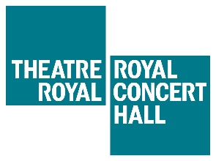
JOIN THE GO CARD SAVER SCHEME

Please complete the form below and return it to BoxOffice.Supervisors@nottinghamcity.gov.uk
along with copy of photo ID that shows your date of birth. Examples of photo ID that we accept are:
• Driving license
• Passport
• Birth Certificate

If you are a full time student who is over the age of 26, please include proof of your student status (such as a letter from your university stating when your course ends and confirming your full time student status).

You can choose whether to have your Go Card posted to you, or to be notified when it is ready to collect from Box Office.

NAME:
EMAIL ADDRESS:
CONTACT NUMBER:
DATE OF BIRTH:
ADDRESS:
TYPE OF PHOTO ID YOU ARE INCLUDING: | Delete as appropriate:  Driving license  Passport  Birth Certificate  Other (please state)
HOW WOULD YOU LIKE TO RECEIVE YOUR GO CARD? | Delete as appropriate:  Please post my Go Card to me  Please leave my Go Card at Box Office for me to collect
FOR OFFICE USE ONLY:
Processed by:
Date:

Constituent ID:

