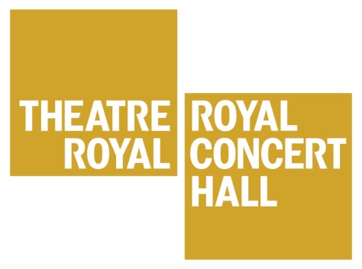
Summer School
Monday 3rd –
Friday 7th August 2020
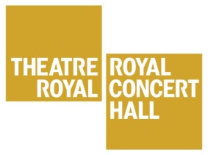
West End in Nottingham is back for 2020!
The West End in Nottingham Summer School is a great opportunity for young people to work with actual West End performers! Over 5 days, participants get to develop their own Musical Theatre talents as well as gain confidence, meet new people and, most importantly, have a lot of fun during the holidays! Each day participants work with a performer from a different West End show. They will learn choreography, songs and scenes as well as get a chance to have their questions answered in the Q and A session with each West End Performer. This year’s shows are Wicked, Joseph and the Amazing Technicolour Dreamcoat, Singin’ in the Rain, and Les Miserables.

Dates and Times
The summer school is divided into two age groups:
- Participants aged 7-10 will meet 9am to 1pm on Monday 3rd to Thursday 6th August.
- Participants aged 11-16 will meet 1.30pm to 5.30pm on Monday 3rd to Thursday 6th August.
- Both groups will meet 10am to 5.30pm on Friday 7th August.

Location: The Royal Concert Hall.
Level access and lifts are available to all floors of the Royal Concert Hall.

Performance: The Royal Concert Hall, Friday 7th August, 5pm.
This is a chance for the participants to share what they have been working on in the week with their family and friends. The performance is free to attend.

Staff
The West End in Nottingham Director is Michael Park. Michael has worked professionally in the performing arts industry for many years as a performer and also in the education sector as a teacher, speaker and course leader. Michael will be supported in his work with an Assistant Director as well as four West End performers. Both Michael and the Assistant director are DBS checked.
A member of the Theatre Royal and Royal Concert Hall’s Creative Learning team will be present at the beginning and end of each session to sign the participants in and out of the building. All Creative Learning Team staff are DBS checked.
The sessions will also be supported by a trained chaperone, also DBS checked, to ensure the security and health and safety of the participants throughout the week. On Friday, the day of the final performance, trained chaperones will be present to ensure the health and safety of the participants, as in accordance with our child protection policy.

Experience
The Summer School is open to all abilities and experiences, we are not looking for participants to have reached certain levels of acting, singing or dancing. Complete beginners are very welcome.

Cost and Enrolment
The cost of this Summer School is £90 per participant.
To enrol on the 2020 West End in Nottingham Summer School, please read the attached terms and conditions carefully and complete and sign the Enrolment Form. Please then return along with your payment to the address listed at the end of the form.

Places are allocated on a first come, first served basis
Once your form and payment have been received, an email will be sent to confirm the places booked. If you have any further queries, please contact Kimberley Allsopp on 0115 989 5539 or kimberley.allsopp@nottinghamcity.gov.uk
WEST END IN NOTTINGHAM SUMMER SCHOOL
Monday 3rd to Friday 7th August 2020
Terms and Conditions

- All participants must be available for all of the dates of the Summer School.
- Participants aged 7-10 will meet 9am to 1pm on Monday 3rd to Thursday 6th August.
- Participants aged 11-16 will meet 1.30pm to 5.30pm on Monday 3rd to Thursday 6th August.
- Both groups will meet 10am to 5.30pm on Friday 7th August.
- Participants are expected to arrive and be collected promptly, at the start and at the end of each session.
- Please provide a suitable drink and a light snack Monday to Thursday and a packed lunch on Friday.
- Participants need to wear clothes that they can dance and move in.
- Participants need to wear dark leggings/trousers/shorts on the Friday for the performance. Each participants will be given a Summer School t-shirt, free of charge.
- Participants are expected to engage properly with Summer School staff, as well as fellow participants throughout the week.
- A place on the Summer School cannot be confirmed until full payment is received.
- If all places on the Summer School have been filled, a waiting list system will then commence. In this situation, payment will be returned and the participant’s details will then go on the waiting list. You will be contacted if a place does becomes available.
- If the Theatre Royal and Royal Concert Hall is unable to attract sufficient participants to make the Summer School cost effective, the Theatre Royal and Royal Concert Hall has the right to cancel the workshop and a full reimbursement will be made to those already booked. This decision will be made no later than week beginning 15th June 2020.
If you are agreement with the above then please sign below.

Name:

Signature:

Relationship to participant:

Date signed:

Please return signed Terms and Conditions and Enrolment form to:

Kimberley Allsopp
Creative Learning Officer
Theatre Royal and Royal Concert Hall
Theatre Square
Nottingham
NG1 5ND

WEST END IN NOTTINGHAM SUMMER SCHOOL
Monday 3rd to Friday 7th August 2020
Enrolment Form
Please complete a separate form for each participant.

Name of Participant:

Date of Birth:
Age on Monday 3rd August 2020:
Any medical or access needs?
Yes / No
If yes, please describe:

Parent/Guardian Name:
Address:

Telephone:

Email:

Please provide an emergency contact – this must be different from the details provided above.
Emergency Contact Name:

Emergency Contact Telephone:

Relationship to participant:

I wish to pay the £90 Summer School fee by the following method (please tick)
Cheque. Made payable to the Royal Centre.
Credit or Debit Card. We will contact you directly for your payment.
Cash. Please do not post. Hand deliver to Theatre Royal Stage Door on Goldsmith Street. Please mark for the attention of Kimberley Allsopp.

Please return your completed form and payment to:
Kimberley Allsopp
Creative Learning Officer
Theatre Royal and Royal Concert Hall
Theatre Square
Nottingham
NG1 5ND

