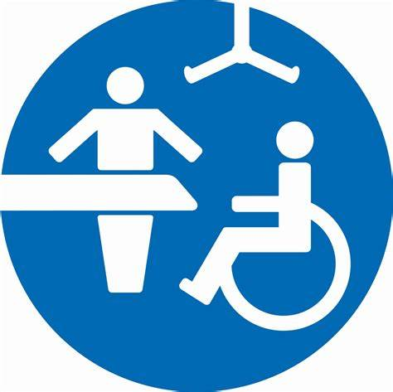

What is a Changing Places toilet?

Standard accessible toilets do not meet the needs of all disabled people.
People with profound and multiple learning disabilities, as well as other serious impairments such as spinal injuries, muscular dystrophy, multiple sclerosis, ostomies or an acquired brain injury, often need extra facilities to allow them to use toilets comfortably, which is where Changing Places facilities come in.

Our Changing Places toilet provides:
The right equipment
- a height adjustable adult-sized changing bench
- a tracking hoist system
- a height adjustable sink
- handrails
- coat hooks at various heights
- A privacy screen

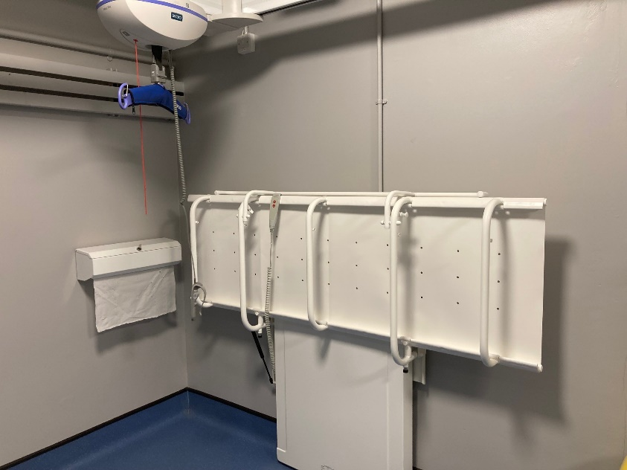
1
2
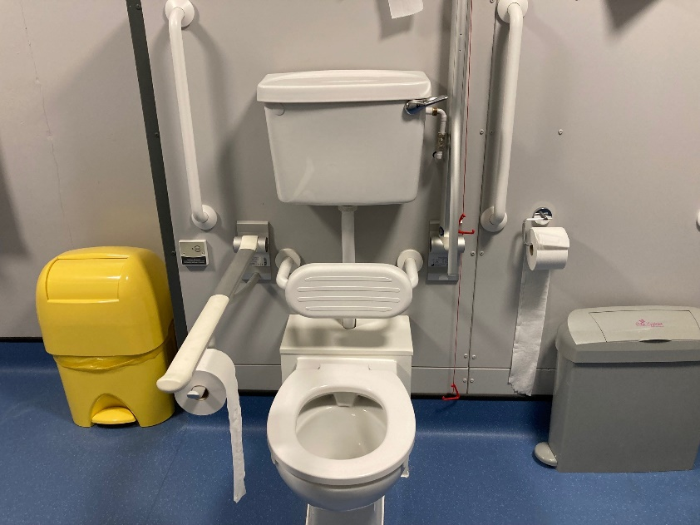
4

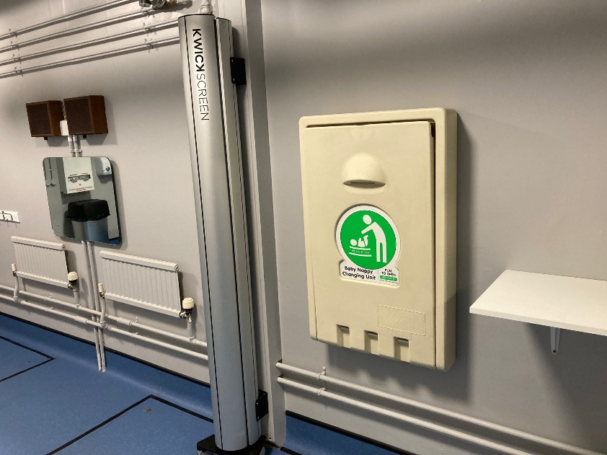
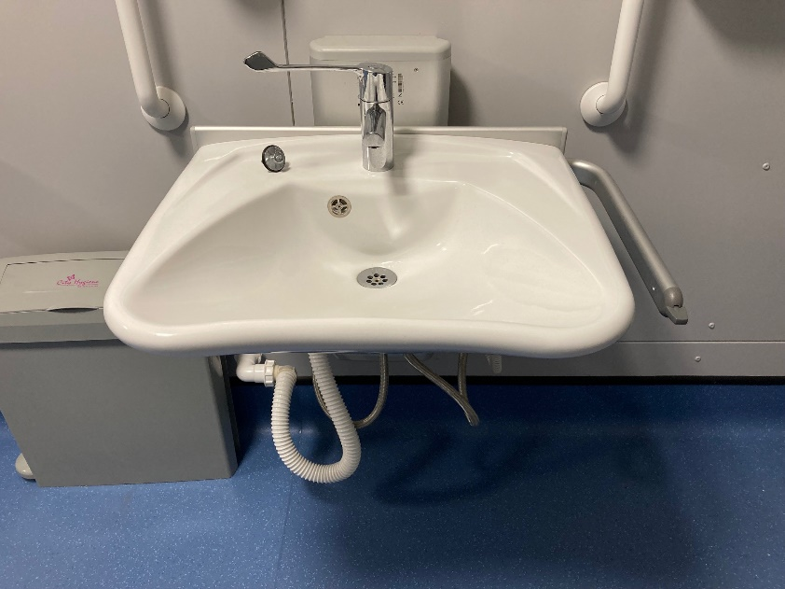
5
6
3

Enough space
- adequate space in the changing area for the disabled person and up to two carers
- a centrally placed toilet with room either side for the carers
- a screen or curtain to allow the disabled person and carer some privacy.

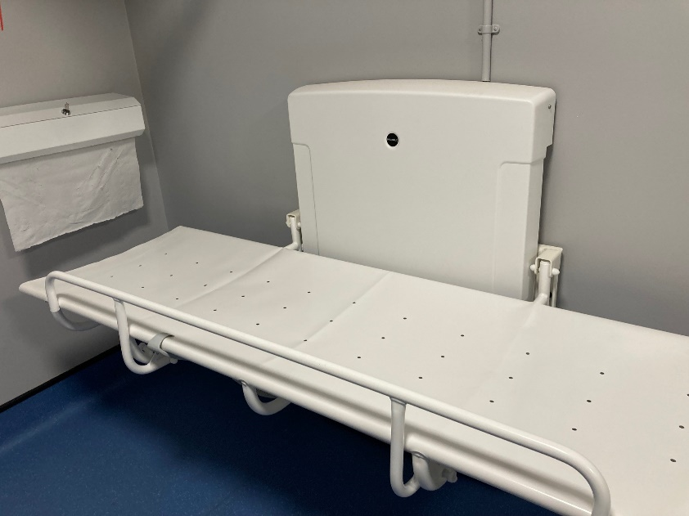
2
1

3

A safe and clean environment
- wide tear off paper roll to cover the bench
- a large waste bin for disposable pads
- a non-slip floor.
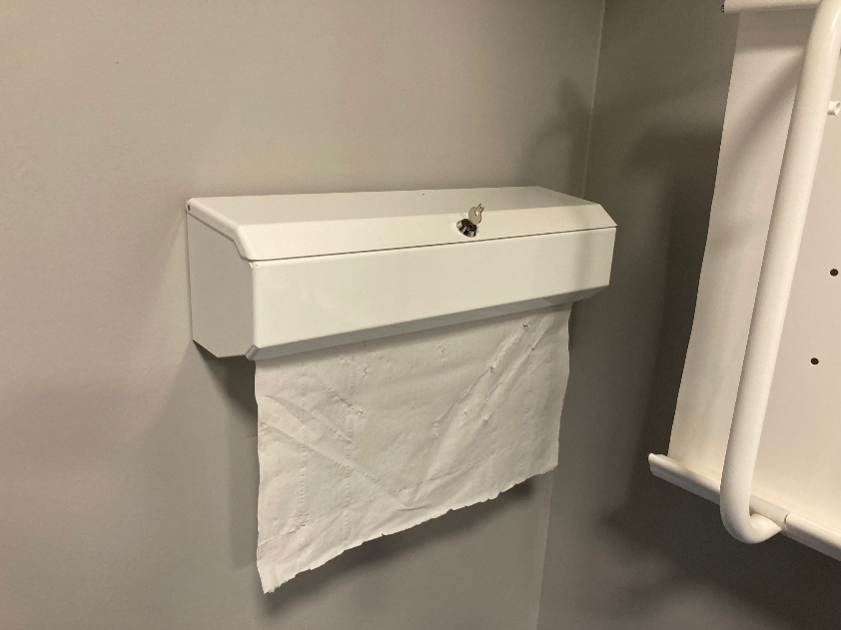
1
3
2

Stoma Friendly Facilities
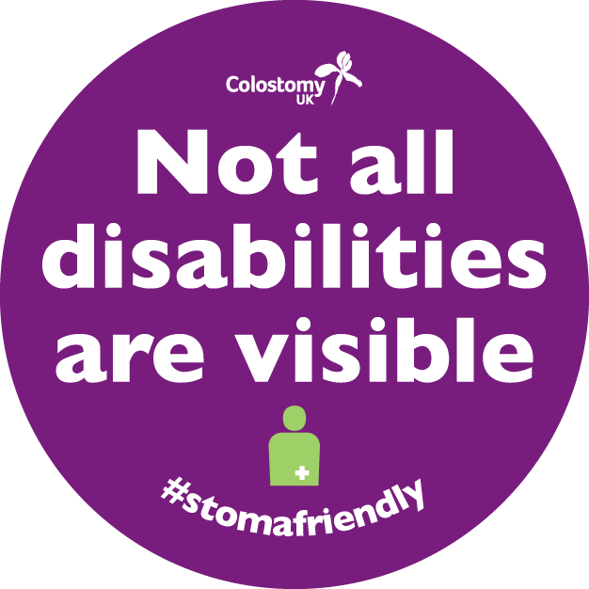
People with a stoma have additional needs when using the toilet; even a simple day trip can be a potential source of anxiety. Because the condition is ‘hidden’, they often face discrimination too, being challenged or criticised for using accessible toilets. We have made the following changes to any toilets in the two venues (including the Changing Places Toilet) that have this logo on the door.

Our Stoma Friendly toilets provide:
- Hooks on door – To hang clothing, handbags while changing stoma bags. This provides more space in the cubicle.
- Shelf space – To enable customers to spread out their items easily and avoid having to use unsanitary surfaces.
- Mirror – To enable users to see their stoma while changing their appliances.
- Disposal bin in every cubicle – To avoid embarrassment for men and women having to dispose of their stoma bag in public

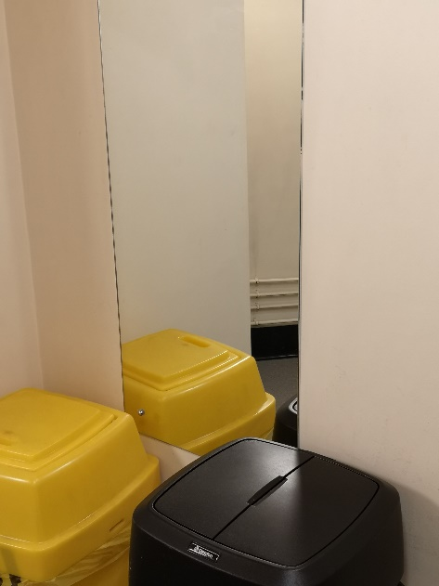
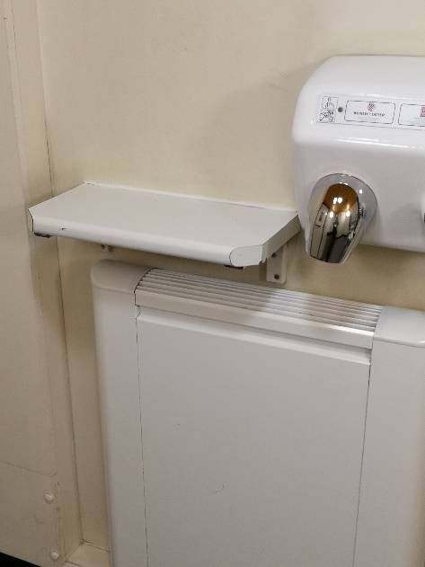
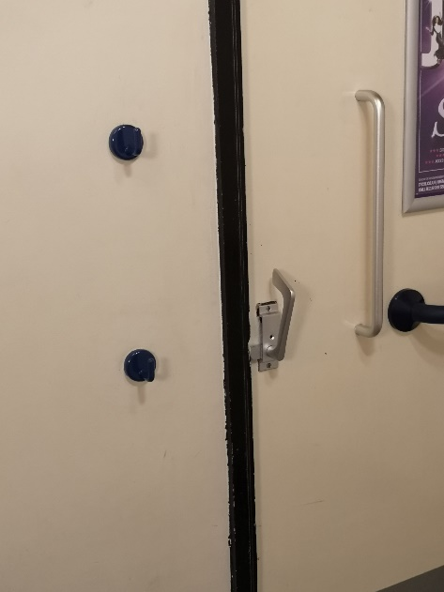
3
4
2
1

